Volunteer Director REQUIRED

Role Title: Director (Trustee)
Location: Basingstoke, Hampshire
Salary: Unremunerated / Voluntary
“I have thoroughly enjoyed my time as a director with YPI, it is a fantastic charity, I am learning as much as I am giving, and it is a joy to work alongside side some amazing individuals"
- Daniel Holloway, Director of Marketing
Supporting hundreds of young people each year, YPI is the leading youth counselling charity in Basingstoke. We provide free Mental Health and emotional support to young people aged 11 to 25, parents and families through a range of interventions including 1-to-1 counselling sessions, group work and psycho-educational activities. We pride ourselves on being a locally run charity with a strong community focus. Throughout our 18-year history we have actively partnered with a variety of local community groups to continuously improve the services available to young people and to develop new services specifically aimed at areas of deprivation or need.
Undertaking the role of Director/Trustee offers the opportunity to shape and develop the strategy and governance of a leading local charity and to assist the organisation in achieving its community objectives and ambitions in the coming years.

General Requirements
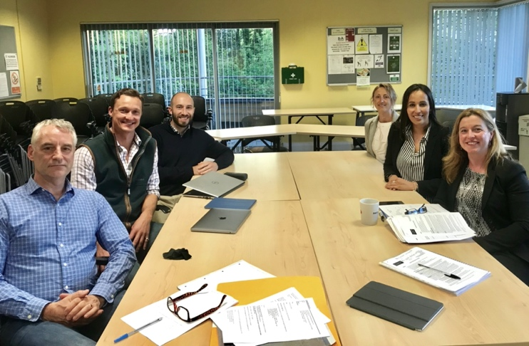
Ideally you can showcase your skills and abilities in supporting strategic planning in relation to organisational performance. A passion for the charity sector, excellent interpersonal skills and your ability to think strategically will be key, as will your track record of sound judgment and effective decision making.
Directors should be available to attend six full Executive Committee meetings each year (along with regular communication via email) and bi-monthly committee meetings where necessary. Meetings take place usually during an evening 7pm-9pm and are held at our offices in Basingstoke (attendance can also be arranged via Skype where required).
Being a YPI Director requires commitment but it is also an extremely rewarding experience.
To apply, please e-mail your CV to Sam Hussey, Chief Executive at: shussey@ypicounselling.co.uk

