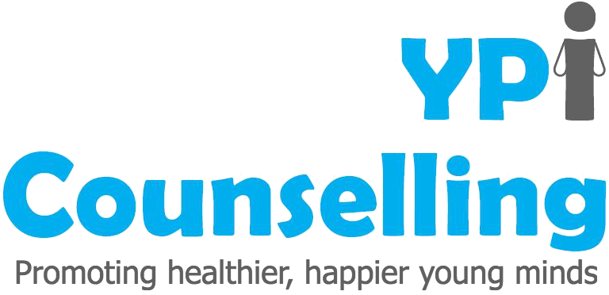
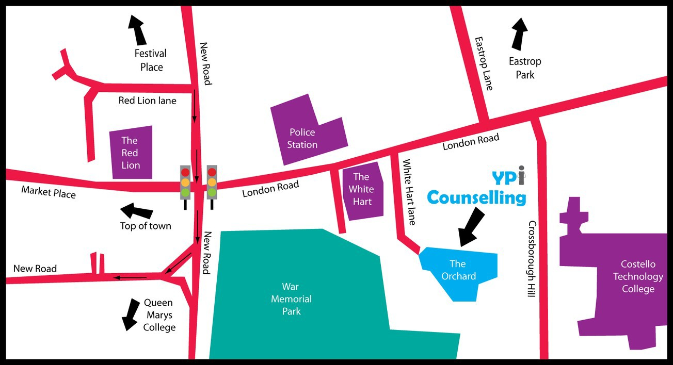
Registered Charity Number: 1163288

If you're feeling unhappy or worried about something then we can help you!

YPI Counselling services offer young people aged 11-25, parents and families to come and talk to a trained Counsellor in a safe space about a wide range of difficulties you may be facing in your life.

Things we can help with include:

- Feeling isolated or lonely
- Self-esteem and identity
- Depression
- Anxiety or mild phobias
- Bullying
- Self-harm or suicidal thoughts
- Anger
- Issues with body image
- Sexuality and gender
- Bereavement
- Relationships
- Issues at school
We are open Monday to Friday offering daytime and evening appointments.

Please call or email us for further information - further details including referral forms can be found on our website.

YPI Counselling The Orchard White Hart
Lane Basingstoke RG214AF
OUR CONTACT DETAILS:
T: 01256-423-878

E: office@ypicounselling.co.uk

W: www.ypicounselling.co.uk

A Parent’s Guide to counselling

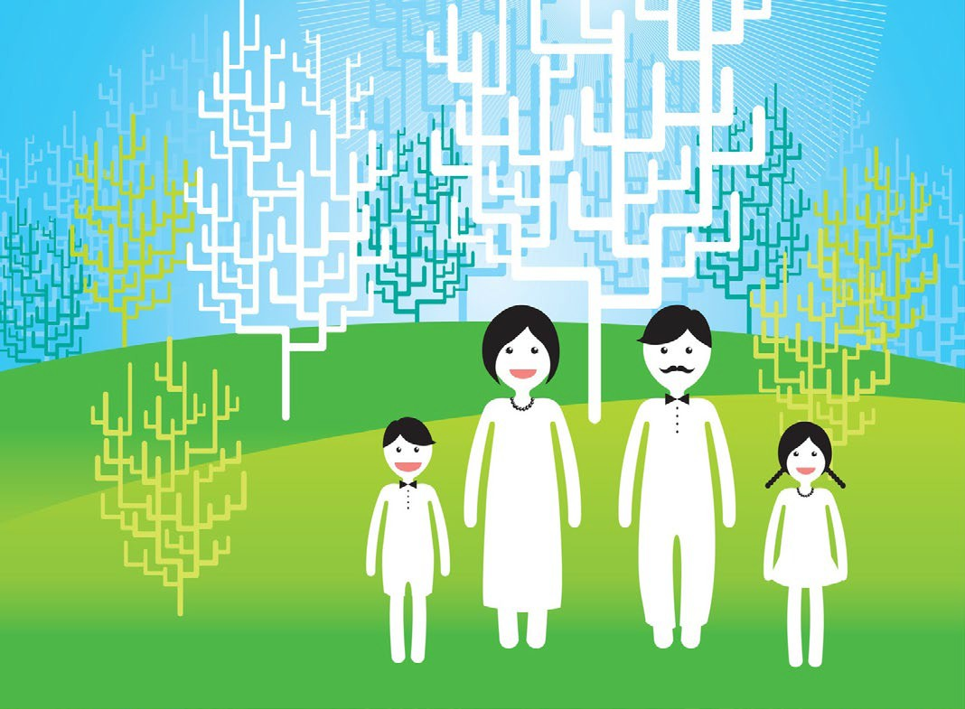
FAQ’s -Youth Counselling

What is counselling?
Counselling is an opportunity for your child to speak to a professional counsellor about their concerns and learn how to cope, manage their feelings, and understand things better.
Counselling is not a treatment for mental health conditions such as PTSD, eating disorders or hearing voices. If you are worried about your child’s mental health, please speak to your GP to discuss a referral to CAMHS (Child and Adolescent Mental Health Services).
If your child is having a mental health crisis, please contact your GP, ring 999 or go to A&E. We can’t see clients outside of their regular appointment times.

How can we get an appointment?

Please discuss the counselling referral with your child first, they will need to be comfortable speaking with the counsellor on their own about the issues. Sometimes even if counselling is needed a child may not feel ready or able to talk about things yet.
Appointments are offered in the order the child is referred. We do not offer quicker appointments based on what is put on the referral form. We do have a waiting list so we may not be able to offer an appointment immediately, but we will make contact as soon as a time becomes free. We may need to speak with your child when we call to find out some more details about what they are experiencing.

To Make a referral please click on the link below to complete an online referral:

www.ypidatabase.co.uk/portal

Can I speak to my child’s counsellor?

What the client says to their counsellor is private – this allows the child to talk about anything without worrying about what others may feel or think about it.

How many sessions can they have?

Generally, 8. We are funded to offer short-term counselling and due to demand can rarely offer more than 8 sessions.
This may mean that your child does not have a chance to speak about everything going on for them. We will ask them to choose the one or two things that are most important for them to speak about in the counselling. You may need to look for further support for them afterwards and we can signpost you to other resources.

How do sessions take place?

Currently YPI offers session by video call (Zoom or MS teams) or face to face at our offices in Basingstoke.
Please note there will be a longer wait time for face to face counselling compared to having appointments video counselling.
The counsellor will therefore not be able to talk to you about what has been said in the sessions.
If you or your child have questions or concerns about the counselling, encourage the child to raise it with their counsellor where possible, their counsellor is there to help them.

If the counsellor feels your child is at risk of harm, they will raise it with the manager. If you have concerns about your child’s wellbeing, we recommend speaking with their GP, or getting support from one of the following helplines:

Young Minds Parent Helpline https://youngminds.org.uk/find-help/for- parents/parents-helpline/
NSPCC
https://www.nspcc.org.uk/keeping- children-safe/support-for-parents/

Family Lives https://www.familylives.org.uk/

